# Tests

| **Test #** | **Test procedure / description** | **Expected Outcome** | **Actual Outcome & Remarks** | **Pass / Fail** |
| --- | --- | --- | --- | --- |
| 1 | 1. make clean 2. make FindFactorsTaskTest 3. valgrind ./FindFactorsTaskTest.out | The FindFactorsTaskTest is run and prints out all the numbers that 1000 is divisibe by, and shows that there are no memory leaks | As expected | Pass |
| 2 | 1. make clean 2. make NumberTest 3. valgrind ./NumberTest.out | The program is run and valgrind shows that there are no memory leaks | As expected | Pass |
| 3 | 1. Start the application 2. Start the server on localhost 3. Connect to the server on localhost | The client connects successfully to the server | As expected | Pass |
| 9 | Repeat test 7 | Same as test 7 | As expected | Pass |

# Bugs

| **Bug #** | **Steps to reproduce & effect** | **Cause** | **How it was resolved** | **Solved** |
| --- | --- | --- | --- | --- |
| 1 | Navigate through some directories, and try to navigate into a directory with elevated privileges.  The application fails to navigate into the directory, and does nothing. | The application does not have the permissions to read the directory. | Run the application in administrator mode | Kind of |
| 2 | Upload a text file to the remote host.  Open the uploaded file on the remote host, and compare the last bit of this file with the last bit of the original file. They do not match. | The protocol for transferring files always writes the whole buffer into the file, even if it was only partially filled with new data from read operations, causing old data to be written to the new file. | Only write as much data to the file as was read from the socket. | Yes; test 8 & 9 |

# Screenshots

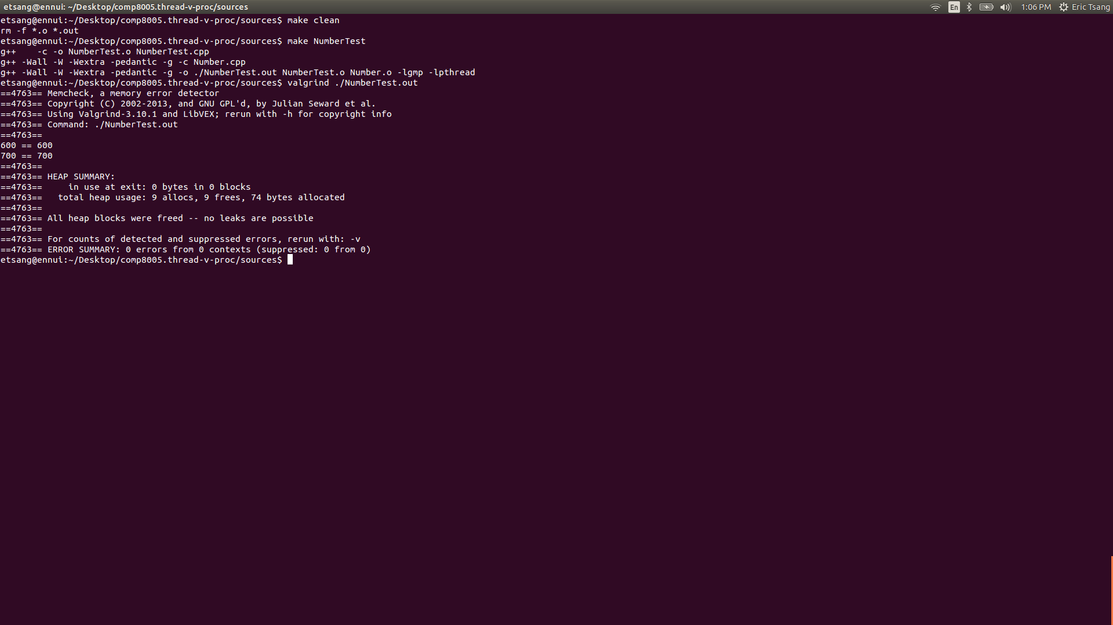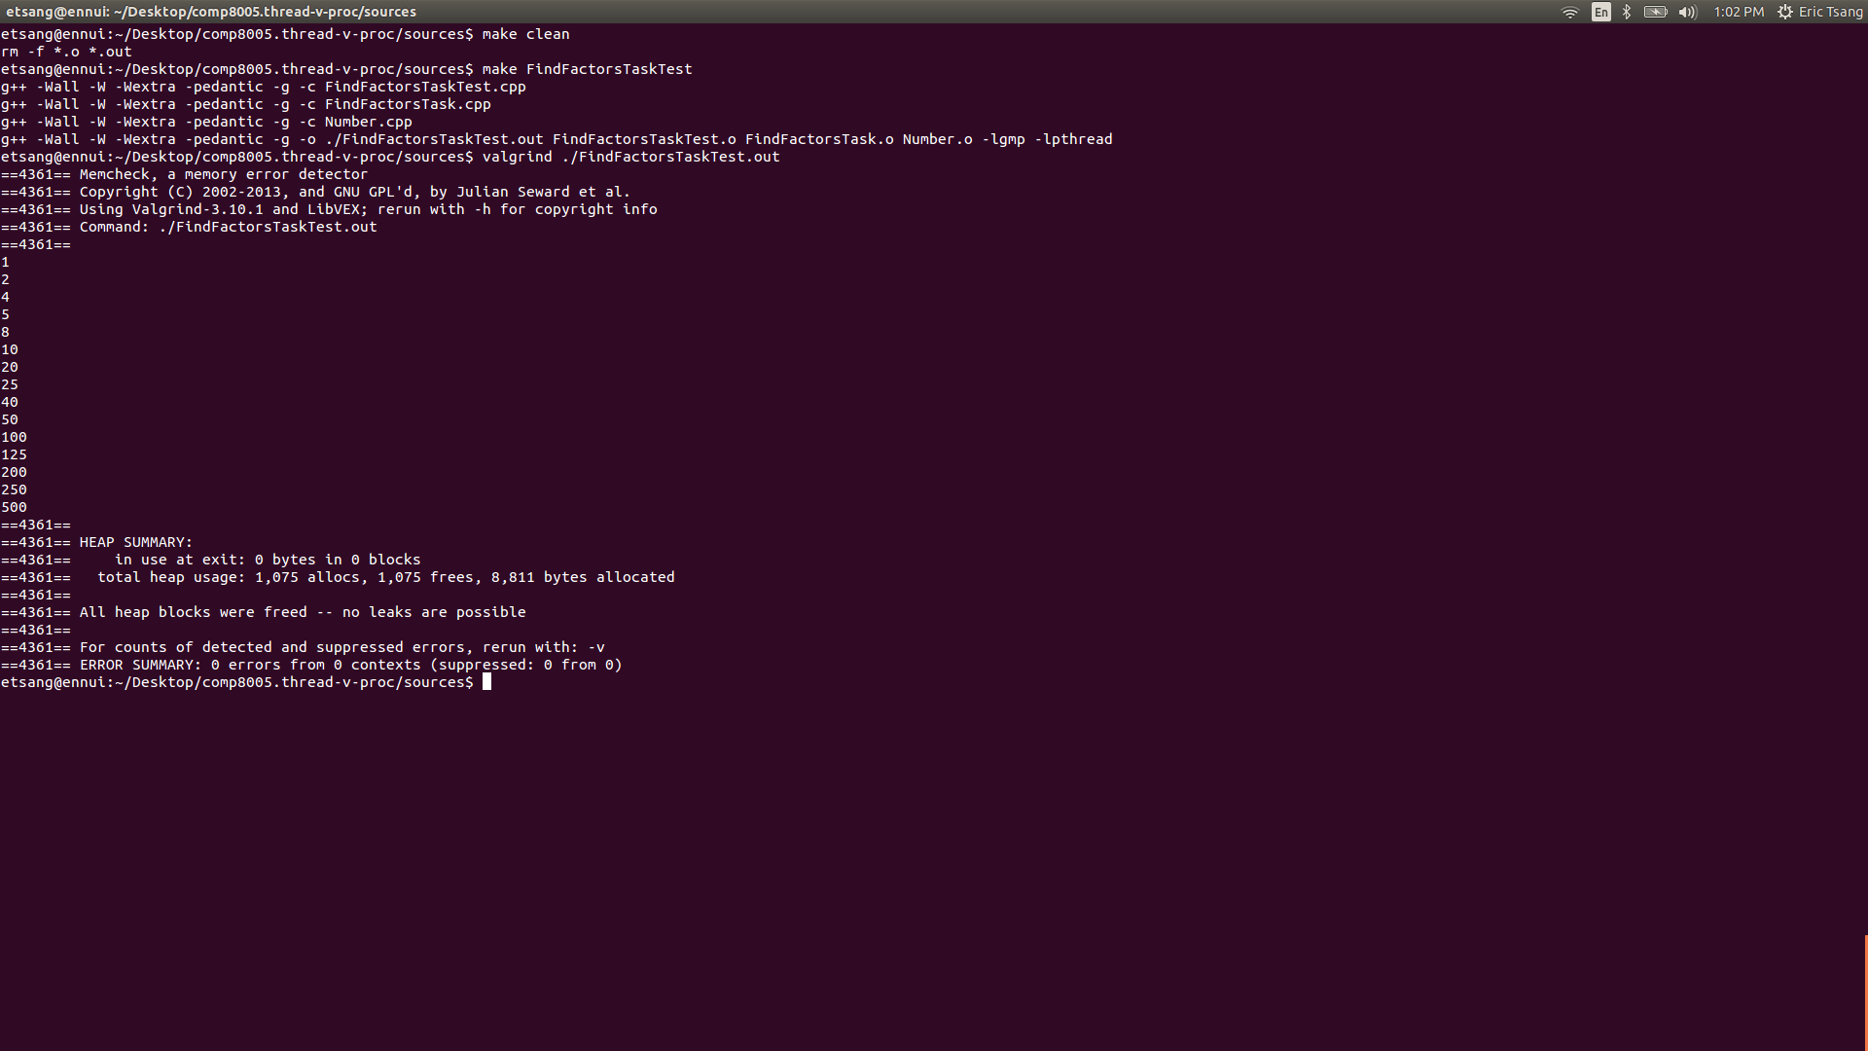

Illustration 1: screenshot of test 1

Illustration 2: screenshot of test 2